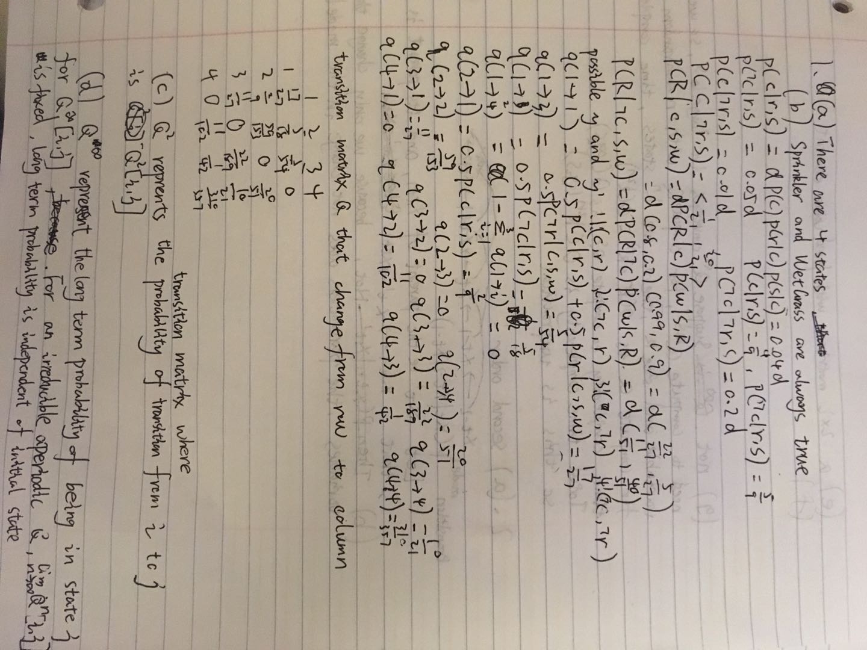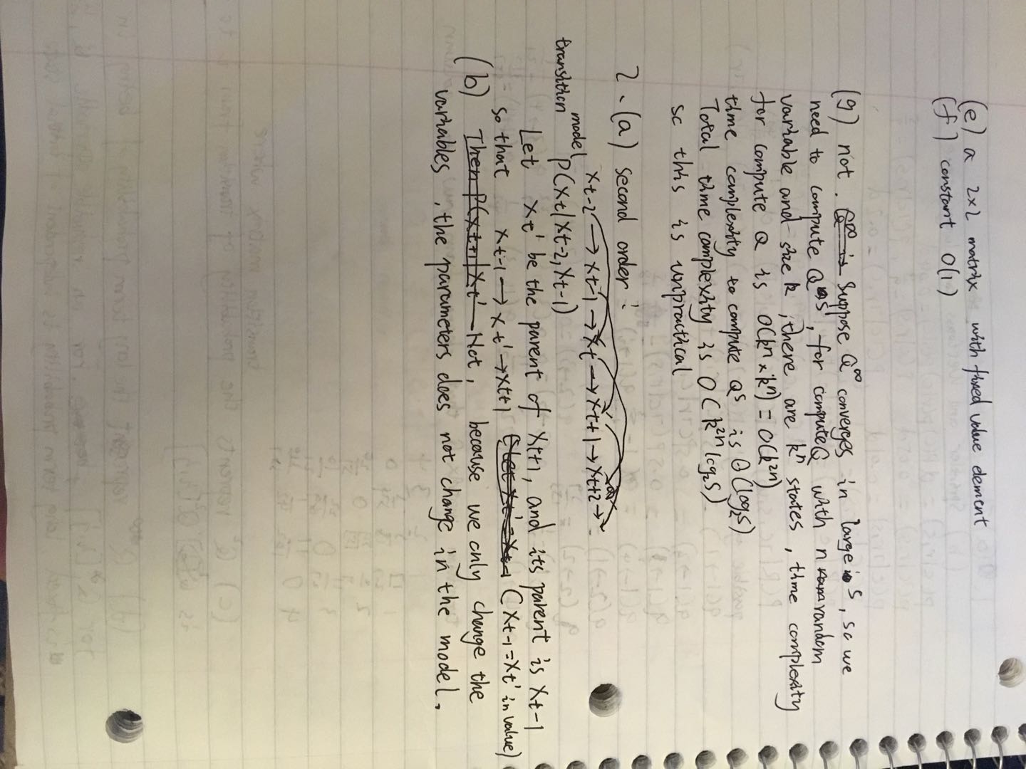

- Instruction:
File: kmean.py generate_test.py
Language:python3.7

For Step2-4: python kmeans.py

Step 2 function: count
Step 3 function: step3, compute_error
Step 4 function: step4

For Step5,bonus1,2: python generate_test.py

Step 5 function: step5, generate, compute_error
Bonus 1 function: bonus1, generate2
Bonus 2 function: bonus2, generate

